**Title Of Project**

**Food Online**

**Table of Contents**

**Title Page Number**

1. **Certificate**
2. **Acknowledgement**
3. **Introduction to Food Online**

* **Project Overview**
* **Project Description**
* **Objectives**

1. **Project Code and Screen Layout**
2. **Testing and Future works**
3. **Conclusion**

**PREFACE**

Effective management of projects is vital for the development of economy because development itself is the effect of series of successful managed projects. This makes project management extremely important problem area for developing economy such as ours. Unfortunately many projects experience schedule slippage and cost overruns due to variety of reasons. To remedy the situation, a project has to be meticulously planned, effectively implemented and professionally managed to achieve the objective of the time, cost and performance. Computerization of the project management can play a major role in streamlining the management of project. Thus we see the computer becoming necessity in the day to day life. The use of computer also involves the feeling of healthy competition with the organization receiving much attention these days. Almost everyday uses of paper carry advertisements asking for project managers. The scenario was not so bright a few years back. For that matter even today though lots of seminars are held on project management, name of the universities in India offer any course to students to formally qualify as project managers. Thus, while there is very little supply. This has created all sorts of problems. Project management, unfortunately, is not but project manager practice, our attempts to demonstrate how project management, as it is concerned, can be put into practice.

**Acknowledgement**

The goal was fixed , the moves were calculated and I moved full of enthusiasm, figurant keen interested there were time , when it proved to be on uphill task , the goal seeming beyond my reach. But as the work progressed my determination and will power grow stronger and the completion of this work further confirmed my belief that, “where there is a will there is a way”.

I am thankful to my guide **Dr. Rakesh Kr. Pandey** and **Dr. Anand Kr.** **Pandey** for his constant encouragement and support to complete the project. He motivated me through his personal and his “never say die” spirit.

I specially would like to express my gratitude and debtless to my friends someway or other and been linked with the project from the one.

I am also grateful to project lab for providing conductive environment.

I would also thank my parents for supporting me in this Project work.

**PROJECT OVERVIEW**

The project entitled “ Food Online“ is done to make the manual process easier by making it a computerised system for adding and maintaining the customer details , order the product, manage the all product, Purchase product , Return the product ,generate bill of purchase items , details and make bill report.

The owner of the Food Online can add new user. They can make the order and generate the bill. If customer want to remove some items or change the quantity then they can do this easily . The application is all make the bill with GST . At the time of purchase the owner can select all items separately they can make bill.

Various report can also be viewed in this project consisting of list of data.

Searchig can also be done . This project displays

Consumer records , employee records , employee payment report , booking list , delivery list and their reports. All the details are easily processed .

**PROJECT DESCRIPTION**

The project named “ Food Online ” is done to make the manual process easier by making it a computerised system for maintaining all the records .

The Owner add new customer , customer can purchase the items category wises. All types of items are categorise in separately such as cakes , cold drinks, chocolate, fast food , sweets etc. Items can be easily purchase and car remove easily and all the data can be stored in the database .This system is very simple and efficient .

Food Online proposed to be an automate database management and transaction. This stores information of Purchase items. Generate bill and store the information of bill and provide the function to manage all things easily. It provides data storing with graphical user interface.

The following are involved in this project :

a). Order Items b). Meal/Dinner

c). Cakes d). Fast Food

e). Cold Drinks f). Chocolate

f). Ice Cream g). Generate Bill

***Objectives***

*The main objective of this project are summarised below:*

* *To design and develop a user friendly efficient computerised Food Online.*
* *An accurate system without data redundancy.*
* *Secured data storage for authority end.*
* *To provide a graphical user interface.*
* *To store large amount of data.*
* *To develop a flexible system which can update and delete the various entered records.*
* *Computerisation that can be helpful as means of saving time and money.*

Main Page

<!DOCTYPE html>

<html>

<head>

<title>FOODONLINE</title>

<link rel="stylesheet" type="text/css" href="style.css">

<link rel="stylesheet" href="https://cdnjs.cloudflare.com/ajax/libs/font-awesome/4.7.0/css/font-awesome.min.css">

</head>

<body>

<div id="x">

<div id="header">

<img src="photo\logo2.jpg" id="logo">

<img src="photo\name.png" id="name">

<img src="photo\Eat.gif" id="Eat" >

</div>

<div class="nav">

<ul>

<li ><a href="Home.html" class="active" target="Content1"><i class="fa fa-home"></i>Home</a></li>

<li>

<a href="About.html" target="Content1"><i class="fa fa-users"></i>About Us</a>

</li>

<li><a href="#"><i class="fa fa-cutlery"></i>Food</a>

<div class="sub-menu-1">

<ul>

<li><a href="Indian.html" target="Content1">Indian</a></li>

<li><a href="Chinese.html" target="Content1">Chinese</a></li>

<li><a href="Bakery.html" target="Content1">Bakery</a></li>

<li><a href="Cold_Drink.html" target="Content1">Cold Drinks</a></li>

</ul>

</div>

</li>

<li><a href="Contact.html" target="Content1"><i class="fa fa-phone"></i>Contact</a></li>

<li><a href="login.html"><i class="fa fa-user"></i>Login</a></li>

</ul>

</div>

<div id="Content">

<iframe src="Home.html" width="100%" name="Content1" height="660px"></iframe>

<!-- <h1>content</h1> -->

<div id="Footer">

<div id="Foot">

<!-- <img src="photo\logo.jpg" style="height: "> -->

<h3>© 2020 ONLINE FOOD </h3>

<p><h2>| Designed and Developed By Pranav Singh Tomar |</h2></p>

</div>

</div>

</body>

</html>

Home Screen

<!DOCTYPE html>

<html>

<head>

<title></title>

<style type="text/css">

*{

margin: 0;

padding: 0;

}

#slide-show{

width: 100%;

height: 530px;

position: absolute;

background-image: url(photo/animation/x1.jpg));

background-size: 100% 100%;

box-shadow: 1px 2px 10px 10px white;

animation: slider 120s infinite linear;

}

@keyframes slider{

0%{

background-image: url(photo/animation/1.jpg);}

8%{

background-image: url(photo/animation/2.jpg);

}

16%{

background-image: url(photo/animation/3.jpg);

}

24%{

background-image: url(photo/animation/4.png);

}

32%{

background-image: url(photo/animation/5.jpg);

}

40%{

background-image: url(photo/animation/6.jpg);

}

48%{

background-image: url(photo/animation/13.jpg);

}

56%{

background-image: url(photo/animation/7.jpg);

}

64%{

background-image: url(photo/animation/8.jpg);}

72%{

background-image: url(photo/animation/9.jpg);

}

80%{

background-image: url(photo/animation/10.jpg);

}

88%{

background-image: url(photo/animation/11.jpg);

}

96%{

background-image: url(photo/animation/12.jpg);

} }

</style>

</head>

<body>

<div style="background-color: ">

<img src="photo/animation/article.jpg" width="100%" height="130px" >

<div id="slide-show"></div>2</div>

</body>

</html>

About page

<!DOCTYPE html>

<html>

<head>

<title>About</title>

<style type="text/css">

h2{

font-weight: 6px;

color: orange;

}

h6

{

color: green;

}

h1

{

color: purple;

}

</style>

</head>

<body background="photo/order.jpg">

<p>

<h1>Food delivery online at your address.</h1>

The first online food order was a pizza from Pizza Hut in 1994.<br>

This is a picture from a 2018 Pizza Hut pizza box, which describes the first online food sale.

The online food ordering market has increased in the U.S with 40 percent of U.S adults having ordered their food online once.[3] The online food ordering market includes foods prepared by restaurants, prepared by independent people, and groceries being ordered online and then picked up or delivered.<br>

The first online food ordering service, World Wide Waiter (now known as Waiter.com), was founded in 1995. The site originally serviced only northern California, later expanding to several additional cities in the United States.<br>

By the late 2000s, major pizza chains had created their own mobile applications and started doing 20–30 percent of their business online.With increased smartphone penetration, and the growth of both Uber and the sharing economy, food delivery startups started to receive more attention. In 2010, Snapfinger, who is a multi-restaurant ordering website, had a growth in their mobile food orders by 17 percent in one year.<br>

By 2015, online ordering began overtaking phone ordering.<br>

In 2015, China's online food ordering and delivery market grew from 0.15 billion yuan to 44.25 billion yuan.<br>

As of September 2016, online delivery accounted for about 3 percent of the 61 billion U.S. restaurant transactions.<br>

<h6>Service types</h6> <br>

A man and a Starship Technologies delivery robot waiting at a pedestrian crossing in Redwood City, California

Restaurant-controlled

In restaurant-controlled online food ordering, the restaurants create their own website and app, or choose to hire a delivery vendor. If they choose to create their own website, they make sure to obtain software that manages the orders efficiently, meaning it has the capability to manage different orders at once. When they hire a vendor, the restaurant pays for a monthly fee or percentage-based fees. The vendor covers the developmental costs.<br>

A customer can choose to have the food delivered or for pick-up. The process consists of a customer choosing the restaurant of their choice, scanning the menu items, choosing an item, and finally choosing for pick-up or delivery. Payment is then administered by paying with a credit card or debit card through the app or website or in cash at the restaurant when going to pickup. The website and app inform the customer of the food quality, duration of food preparation, and when the food is ready for pick-up or the amount of time it will take for delivery. Papa John's is one of the restaurants that created their own Papa John's system, website, and app, and do their own delivery.In 2010, they redesigned their website and launched mobile apps for iPhones, iPads, iPods, Androids Phones, Blackberrys, and Windows Phones.<br>

The preexisting delivery infrastructure of these franchises paired with the online ordering system. In 2010, Papa John's International announced that its online sales had exceeded $2 billion.<br>

<h6>Independent</h6>

This section does not cite any sources. Please help improve this section by adding citations to reliable sources. Unsourced material may be challenged and removed. (January 2019) (Learn how and when to remove this template message)

In this case, a person cooks and offers meals or kits via their website, which are then directly sent to consumers. The consumer chooses which meal and how many meals they want sent to their office or home, and pays depending on the meals or the program they are interested in. People choose to order meals from other people for different reasons: not wanting or having time to cook, wanting to eat home-cooked meals, or to lose weight by eating healthy foods. Examples of this type of service include DineWise, NutriSystem, Chef's Diet, etc.<br>

<h6>Food cooperatives</h6>

Some food cooperatives like Macomb Co-op allow members to place orders of locally grown and/or produced food online and pick up and pay for their orders at a central location.<br>

<h6>Food riders and drivers</h6>

The riders and drivers for nearly all independent restaurant delivery app services are independent contractors, having the flexibility to choose when they work.[17]. In Australia, specifically riders for the food app of Foodora, consider themselves employees because they sometimes work full time hours, are required to wear uniforms, and do set shifts.<br>

However, food delivery riders and drivers usually do not receive any insurance coverage, protective gear, or sick pay as independent contractors, which have led to some asking for improved safety standards.[19] In response, Deliveroo gave riders a helmet with a GoPro camera to record any problems they may face, specifically with criminals. The riders have the opportunity to raise safety concerns about delivery areas in the app.<br></p>

<br><p> <h2>Delivery.com</h2>

Delivery.com LLC<br>

Type of business Private<br>

Type of site Online ordering<br>

Headquarters New York City, New York<br>

Area served United States<br>

Key people Jed Kleckner

(CEO)<br>

<h6>URL delivery.com</h6>

Delivery.com LLC is an online platform and suite of mobile apps that enables users to order from local restaurants and stores for on-demand delivery. The company currently has more than one million users and an online marketplace of more than 12,000 restaurants, wine and liquor stores, grocery stores, and laundry/dry cleaning providers.<br>

Headquartered in New York, delivery.com offers service in over one hundred cities across the United States, including Chicago, Boston, San Francisco, Los Angeles, and Washington D.C. In 2014, delivery.com expanded into Hong Kong. The Hong Kong assets were then sold to Foodpanda in 2016, ending delivery.com's international business.<br>

<h1>Products and services</h1>

<h2>Online ordering</h2>

Users can place orders online at www.delivery.com or download the mobile app for iOS or Android. To place an order, the user must first enter their address to find out what merchants are available for delivery or pickup. From there, they can add items to their “bag”, including food, alcohol, groceries, or laundry services like wash-and-fold, dry cleaning, or tailoring. Secure payment methods available to delivery.com users include credit card, PayPal, Apple Pay, Visa Checkout, or cash.[8] They also have the option to leave a tip at the time of checkout.<br>

As a marketplace platform, delivery.com does not make or prepare food, nor does it handle laundry or deliver any of the items sold. When a user places an order, the order details are automatically sent to the intended merchant; the merchant confirms receipt from delivery.com then prepares and delivers the order.<br>

<h2>API Partners</h2>

Delivery.com offers an open Developer API that enables developers to tap into its merchant.[9] As a result of these efforts, delivery.com currently powers online ordering for a number of companies and third-party apps, including WeWork, LevelUp, BringMeThat.com, Menuless.com Zipongo, Foodme.io, and others.<br>

On February 11, 2016, delivery.com announced an integration with Foursquare, powering online ordering for the local discovery app.[13]

</p></body></html>

Bakery

<!DOCTYPE html>

<html>

<head>

<meta name="viewport" content="width=device-width, initial-scale=1">

<style>

* {

box-sizing: border-box;

}

.column {

float: left;

width: 20%;

padding: 2px;

height: 300px; /* Should be removed. Only for demonstration */

}

.row:after {

content: "";

display: table;

clear: both;

}

img{

width: 250px;

height: 230px;

}

p{

margin: 0;

font-family: Comic Sans MS;

color: green;

font-weight: 16px;

}

input

{

text-align: center;

}

</style>

</head>

<body>

<center>

<p>CAKE</p>

<div class="row">

<div class="column" style="background-color:#aaa;">

<div id="A">

<img src="photo\food\b1.jpg">

<p>Per Price 12 RS. only</p>

</div>

<div id="B">

<input type="button" name="minus" value="-" onclick="sub()">

<input type="text" name="" placeholder="0" value="0" id="ii1">

<input type="button" name="plus" value="+" onclick="sum()">

</div> </div>

<div class="column" style="background-color:#bbb;">

<div id="A">

<img src="photo\food\b2.jpg">

<p>Per Price 25 RS. only</p>

</div>

<div id="B">

<input type="button" name="minus" value="-" onclick="sub2()">

<input type="text" name="" placeholder="0" value="0" id="ii2">

<input type="button" name="plus" value="+" onclick="sum2()">

</div> </div>

<div class="column" style="background-color:#ccc;">

<div id="A">

<img src="photo\food\b3.jpg">

<p>Per Price 15 RS. only</p>

</div>

<div id="B">

<input type="button" name="minus" value="-" onclick="sub3()">

<input type="text" name="" placeholder="0" value="0" id="ii3">

<input type="button" name="plus" value="+" onclick="sum3()">

</div>

</div>

<div class="column" style="background-color:#aaa;">

<div id="A">

<img src="photo\food\b4.jpg">

<p>Per Price 20 RS. only</p>

</div>

<div id="B">

<input type="button" name="minus" value="-" onclick="sub4()">

<input type="text" name="" placeholder="0" value="0" id="ii4">

<input type="button" name="plus" value="+" onclick="sum4()">

</div> </div>

<div class="column" style="background-color:#bbb;">

<div id="A">

<img src="photo\food\b5.jpg">

<p>Per Price 75 RS. only</p>

</div>

<div id="B">

<input type="button" name="minus" value="-" onclick="sub5()">

<input type="text" name="" placeholder="0" value="0" id="ii5">

<input type="button" name="plus" value="+" onclick="sum5()">

</div> </div></div>

<p>ICE CREAM</p>

<div class="row">

<div class="column" style="background-color:#aaa;">

<div id="A">

<img src="photo\food\b6.jpg">

<p>Per Price 60 RS. only</p>

</div>

<div id="B">

<input type="button" name="minus" value="-" onclick="sub6()">

<input type="text" name="" placeholder="0" value="0" id="ii6">

<input type="button" name="plus" value="+" onclick="sum6()">

</div> </div>

<div class="column" style="background-color:#bbb;">

<div id="A">

<img src="photo\food\b7.jpg">

<p>Per Price 50 RS. only</p>

</div>

<div id="B">

<input type="button" name="minus" value="-" onclick="sub7()">

<input type="text" name="" placeholder="0" value="0" id="ii7">

<input type="button" name="plus" value="+" onclick="sum7()">

</div> </div>

<div class="column" style="background-color:#ccc;">

<div id="A">

<img src="photo\food\b8.jpg">

<p>Per Price 40 RS. only</p>

</div>

<div id="B">

<input type="button" name="minus" value="-" onclick="sub8()">

<input type="text" name="" placeholder="0" value="0" id="ii8">

<input type="button" name="plus" value="+" onclick="sum8()">

</div> </div>

<div class="column" style="background-color:#aaa;">

<div id="A">

<img src="photo\food\b9.jpg">

<p>Per Price 90 RS. only</p>

</div>

<div id="B">

<input type="button" name="minus" value="-" onclick="sub9()">

<input type="text" name="" placeholder="0" value="0" id="ii9">

<input type="button" name="plus" value="+" onclick="sum9()">

</div> </div>

<div class="column" style="background-color:#bbb;">

<div id="A">

<img src="photo\food\b10.jpg">

<p>Per Price 80 RS. only</p>

</div>

<div id="B">

<input type="button" name="minus" value="-" onclick="sub10()">

<input type="text" name="" placeholder="0" value="0" id="ii10">

<input type="button" name="plus" value="+" onclick="sum10()">

</div> </div> </div>

<p>CHOCLATE</p>

<div class="row">

<div class="column" style="background-color:#aaa;">

<div id="A">

<img src="photo\food\b11.jpg">

<p>Per Price 120 RS. only</p>

</div>

<div id="B">

<input type="button" name="minus" value="-" onclick="sub11()">

<input type="text" name="" placeholder="0" value="0" id="ii11">

<input type="button" name="plus" value="+" onclick="sum11()">

</div> </div>

<div class="column" style="background-color:#bbb;">

<div id="A">

<img src="photo\food\b12.jpg">

<p>Per Price 120 RS. only</p>

</div>

<div id="B">

<input type="button" name="minus" value="-" onclick="sub12()">

<input type="text" name="" placeholder="0" value="0" id="ii12">

<input type="button" name="plus" value="+" onclick="sum12()">

</div> </div>

<div class="column" style="background-color:#ccc;">

<div id="A">

<img src="photo\food\b13.jpg">

<p>Per Price 120 RS. only</p>

</div>

<div id="B">

<input type="button" name="minus" value="-" onclick="sub13()">

<input type="text" name="" placeholder="0" value="0" id="ii13">

<input type="button" name="plus" value="+" onclick="sum13()">

</div> </div>

<div class="column" style="background-color:#aaa;">

<div id="A">

<img src="photo\food\b14.jpg">

<p>Per Price 120 RS. only</p>

</div>

<div id="B">

<input type="button" name="minus" value="-" onclick="sub14()">

<input type="text" name="" placeholder="0" value="0" id="ii14">

<input type="button" name="plus" value="+" onclick="sum14()">

</div> </div>

<div class="column" style="background-color:#bbb;">

<div id="A">

<img src="photo\food\b15.jpg">

<p>Per Price 120 RS. only</p>

</div>

<div id="B">

<input type="button" name="minus" value="-" onclick="sub15()">

<input type="text" name="" placeholder="0" value="0" id="ii15">

<input type="button" name="plus" value="+" onclick="sum15()">

</div> </div> </div>

<a href="Home.html"> <button value="Cancel" style="color: white; height: 50px; width:120px; background-color: red;">Cancel</button></a>

<button value="Cancel" style="color: white; height: 50px; width:120px; background-color: green;" onclick="Bill()">Pay Bill</button>

</center>

<script type="text/javascript">

function Bill()

{

var Total_Bill=0;

var i=0;

var Bill=[15];

var Bill1=0,Bill2=0,Bill3=0,Bill5=0,Bill4=0,Bill10=0,Bill6=0,Bill7=0,Bill8=0,Bill9=0,Bill11=0,Bill12=0,Bill13=0,Bill15=0,Bill14=0;

if(document.getElementById('ii1').value>0)

{

Bill1=(document.getElementById('ii1').value*12);

Bill[i]="Fruit Cake x "+ document.getElementById('ii1').value +" piece = "+Bill1;

i++;

}

if(document.getElementById('ii2').value>0)

{

Bill2=(document.getElementById('ii2').value*25);

Bill[i]=("Vaivate Cake x "+ document.getElementById('ii2').value +" piece = "+Bill2);

i++;

}

if(document.getElementById('ii3').value>0)

{

Bill3=(document.getElementById('ii3').value*15);

Bill[i]=("Choclate Cake x "+ document.getElementById('ii3').value +" piece = "+Bill3);

i++

}

if(document.getElementById('ii4').value>0)

{

Bill4=(document.getElementById('ii4').value*20);

Bill[i]=("Cake x "+ document.getElementById('ii4').value +" piece = "+Bill4);

i++;

}

if(document.getElementById('ii5').value>0)

{

Bill5=(document.getElementById('ii5').value*75);

Bill[i]=("Pie Cake x "+ document.getElementById('ii5').value +" piece = "+Bill5);

i++;

}

if(document.getElementById('ii6').value>0)

{

Bill6=(document.getElementById('ii6').value*60);

Bill[i]=("Oreo Ice-Cream x "+ document.getElementById('ii6').value +" piece = "+Bill6);

i++;

}

if(document.getElementById('ii7').value>0)

{

Bill7=(document.getElementById('ii7').value*50);

Bill[i]=("Cup Ice-Cream x "+ document.getElementById('ii7').value +" piece = "+Bill7);

i++;

}

if(document.getElementById('ii8').value>0)

{

Bill8=(document.getElementById('ii8').value*40);

Bill[i]=("Stick Ice-Cream x "+ document.getElementById('ii8').value +" piece = "+Bill8);

i++;

}

if(document.getElementById('ii9').value>0)

{

Bill9=(document.getElementById('ii9').value*90);

Bill[i]="Glass Ice-Cream x "+ document.getElementById('ii9').value +" piece = "+Bill9+"\n";

i++;

}

if(document.getElementById('ii10').value>0)

{

Bill10=(document.getElementById('ii10').value*80);

Bill[i]=("Ball Ice-Cream x "+ document.getElementById('ii10').value +" piece = "+Bill10);

i++;

}

if(document.getElementById('ii11').value>0)

{

Bill11=(document.getElementById('ii11').value*120);

Bill[i]=("Dairy Milk x "+ document.getElementById('ii11').value +" piece = "+Bill11);

i++;

}

if(document.getElementById('ii12').value>0)

{

Bill12=(document.getElementById('ii12').value*120);

Bill[i]=("Kit-Kat x "+ document.getElementById('ii12').value +" piece = "+Bill12);

i++;

}

if(document.getElementById('ii13').value>0)

{

Bill13=(document.getElementById('ii13').value*120);

Bill[i]=("Pulse x "+ document.getElementById('ii13').value +" piece = "+Bill13);

i++;

}

if(document.getElementById('ii14').value>0)

{

Bill14=(document.getElementById('ii14').value*120);

Bill[i]="Bounvile x "+ document.getElementById('ii14').value +" piece = "+Bill14+"\n";

i++;

}

if(document.getElementById('ii15').value>0)

{

Bill15=(document.getElementById('ii15').value*120);

Bill[i]="Celebration x "+ document.getElementById('ii15').value +" piece = "+Bill15+"\n";

i++;

} Total_Bill=Bill1+Bill2+Bill3+Bill4+Bill5+Bill6+Bill7+Bill8+Bill9+Bill10+Bill11+Bill12+Bill13+Bill14+Bill15;

Bill[i]="Total_Bill ="+Total_Bill;

for (var i = 0; i < Bill.length; i++) {

document.write(Bill[i]+"<br>");

}

// alert(a1+"\n"+a2+"\n"+a3+"\n"+a4+"\n"+a5+"\n"+"Total = "+Total_Bill);

}

function sub(argument)

{

x=document.getElementById('ii1').value;

if (x>0)

{

x--;

document.getElementById('ii1').value=x;

} }

function sum(argument)

{

y=document.getElementById('ii1').value;

if (y>=0)

{

y++;

document.getElementById('ii1').value=y;

}

}

function sub2(argument)

{

x=document.getElementById('ii2').value;

if (x>0)

{

x--;

document.getElementById('ii2').value=x;

} }

function sum2(argument)

{

y=document.getElementById('ii2').value;

if (y>=0)

{

y++;

document.getElementById('ii2').value=y;

}

}

function sub3(argument)

{

x=document.getElementById('ii3').value;

if (x>0)

{

x--;

document.getElementById('ii3').value=x;

} }

function sum3(argument)

{

y=document.getElementById('ii3').value;

if (y>=0)

{

y++;

document.getElementById('ii3').value=y;

} }

function sub4(argument)

{

x=document.getElementById('ii4').value;

if (x>0)

{

x--;

document.getElementById('ii4').value=x;

} }

function sum4(argument)

{

y=document.getElementById('ii4').value;

if (y>=0)

{

y++;

document.getElementById('ii4').value=y;

} }

function sub5(argument)

{

x=document.getElementById('ii5').value;

if (x>0)

{

x--;

document.getElementById('ii5').value=x;

} }

function sum5(argument)

{

y=document.getElementById('ii5').value;

if (y>=0)

{

y++;

document.getElementById('ii5').value=y;

} }

function sub6(argument)

{

x=document.getElementById('ii6').value;

if (x>0)

{

x--;

document.getElementById('ii6').value=x;

} }

function sum6(argument)

{

y=document.getElementById('ii6').value;

if (y>=0)

{

y++;

document.getElementById('ii6').value=y;

}

}

function sub7(argument)

{

x=document.getElementById('ii7').value;

if (x>0)

{

x--;

document.getElementById('ii7').value=x;

} }

function sum7(argument)

{

y=document.getElementById('ii7').value;

if (y>=0)

{

y++;

document.getElementById('ii7').value=y;

} }

function sub8(argument)

{

x=document.getElementById('ii8').value;

if (x>0)

{

x--;

document.getElementById('ii8').value=x;

} }

function sum8(argument)

{

y=document.getElementById('ii8').value;

if (y>=0)

{

y++;

document.getElementById('ii8').value=y;

} }

function sub9(argument)

{

x=document.getElementById('ii9').value;

if (x>0)

{

x--;

document.getElementById('ii9').value=x;

}

}

function sum9(argument)

{

y=document.getElementById('ii9').value;

if (y>=0)

{

y++;

document.getElementById('ii9').value=y;

} }

function sub10(argument)

{

x=document.getElementById('ii10').value;

if (x>0)

{

x--;

document.getElementById('ii10').value=x;

} }

function sum10(argument)

{

y=document.getElementById('ii10').value;

if (y>=0)

{

y++;

document.getElementById('ii10').value=y;

} }

function sub11(argument)

{

x=document.getElementById('ii11').value;

if (x>0)

{

x--;

document.getElementById('ii11').value=x;

} }

function sum11(argument)

{

y=document.getElementById('ii11').value;

if (y>=0)

{

y++;

document.getElementById('ii11').value=y;

} }

function sub12(argument)

{

x=document.getElementById('ii12').value;

if (x>0)

{

x--;

document.getElementById('ii12').value=x;

} }

function sum12(argument)

{

y=document.getElementById('ii12').value;

if (y>=0)

{

y++;

document.getElementById('ii12').value=y;

} }

function sub13(argument)

{

x=document.getElementById('ii13').value;

if (x>0)

{

x--;

document.getElementById('ii13').value=x;

} }

function sum13(argument)

{

y=document.getElementById('ii13').value;

if (y>=0)

{

y++;

document.getElementById('ii13').value=y;

}

}

function sub14(argument)

{

x=document.getElementById('ii14').value;

if (x>0)

{

x--;

document.getElementById('ii14').value=x;

} }

function sum14(argument)

{

y=document.getElementById('ii14').value;

if (y>=0)

{

y++;

document.getElementById('ii14').value=y;

} }

function sub15(argument)

{

x=document.getElementById('ii15').value;

if (x>0)

{

x--;

document.getElementById('ii15').value=x;

} }

function sum15(argument)

{

y=document.getElementById('ii15').value;

if (y>=0)

{

y++; document.getElementById('ii15').value=y;

} }

</script></body>

</html>

Chinese

<!DOCTYPE html>

<html>

<head>

<meta name="viewport" content="width=device-width, initial-scale=1">

<style>

* {

box-sizing: border-box;

}

.column {

float: left;

width: 20%;

padding: 2px;

height: 300px;

}

.row:after {

content: "";

display: table;

clear: both;

}

img{

width: 250px;

height: 230px;

}

p{

margin: 0;

font-family: Comic Sans MS;

color: green;

font-weight: 16px;

}

input{

text-align: center;

}

</style>

</head>

<body>

<center>

<p>CHOWMIEN</p>

<div class="row">

<div class="column" style="background-color:#aaa;">

<div id="A">

<img src="photo\food\c1.jpg">

<p>Per Price 12 RS. only</p>

</div>

<div id="B">

<input type="button" name="minus" value="-" onclick="sub()">

<input type="text" name="" placeholder="0" value="0" id="ii1">

<input type="button" name="plus" value="+" onclick="sum()">

</div> </div>

<div class="column" style="background-color:#bbb;">

<div id="A">

<img src="photo\food\c2.jpg">

<p>Per Price 25 RS. only</p>

</div>

<div id="B">

<input type="button" name="minus" value="-" onclick="sub2()">

<input type="text" name="" placeholder="0" value="0" id="ii2">

<input type="button" name="plus" value="+" onclick="sum2()">

</div> </div>

<div class="column" style="background-color:#ccc;">

<div id="A">

<img src="photo\food\c3.jpg">

<p>Per Price 15 RS. only</p>

</div>

<div id="B">

<input type="button" name="minus" value="-" onclick="sub3()">

<input type="text" name="" placeholder="0" value="0" id="ii3">

<input type="button" name="plus" value="+" onclick="sum3()">

</div> </div>

<div class="column" style="background-color:#aaa;">

<div id="A">

<img src="photo\food\c4.jpg">

<p>Per Price 20 RS. only</p>

</div>

<div id="B">

<input type="button" name="minus" value="-" onclick="sub4()">

<input type="text" name="" placeholder="0" value="0" id="ii4">

<input type="button" name="plus" value="+" onclick="sum4()">

</div>

</div>

<div class="column" style="background-color:#bbb;">

<div id="A">

<img src="photo\food\c5.jpg">

<p>Per Price 75 RS. only</p>

</div>

<div id="B">

<input type="button" name="minus" value="-" onclick="sub5()">

<input type="text" name="" placeholder="0" value="0" id="ii5">

<input type="button" name="plus" value="+" onclick="sum5()">

</div></div></div>

<p>Rolls</p>

<div class="row">

<div class="column" style="background-color:#aaa;">

<div id="A">

<img src="photo\food\c6.jpg">

<p>Per Price 50 RS. only</p>

</div>

<div id="B">

<input type="button" name="minus" value="-" onclick="sub6()">

<input type="text" name="" placeholder="0" value="0" id="ii6">

<input type="button" name="plus" value="+" onclick="sum6()">

</div> </div>

<div class="column" style="background-color:#bbb;">

<div id="A">

<img src="photo\food\c7.jpg">

<p>Per Price 80 RS. only</p>

</div>

<div id="B">

<input type="button" name="minus" value="-" onclick="sub7()">

<input type="text" name="" placeholder="0" value="0" id="ii7">

<input type="button" name="plus" value="+" onclick="sum7()">

</div> </div>

<div class="column" style="background-color:#ccc;">

<div id="A">

<img src="photo\food\c8.jpg">

<p>Per Price 60 RS. only</p>

</div>

<div id="B">

<input type="button" name="minus" value="-" onclick="sub8()">

<input type="text" name="" placeholder="0" value="0" id="ii8">

<input type="button" name="plus" value="+" onclick="sum8()">

</div></div>

<div class="column" style="background-color:#aaa;">

<div id="A">

<img src="photo\food\c9.jpg">

<p>Per Price 40 RS. only</p>

</div>

<div id="B">

<input type="button" name="minus" value="-" onclick="sub9()">

<input type="text" name="" placeholder="0" value="0" id="ii9">

<input type="button" name="plus" value="+" onclick="sum9()">

</div></div>

<div class="column" style="background-color:#bbb;">

<div id="A">

<img src="photo\food\c10.jpg">

<p>Per Price 60 RS. only</p>

</div>

<div id="B">

<input type="button" name="minus" value="-" onclick="sub10()">

<input type="text" name="" placeholder="0" value="0" id="ii10">

<input type="button" name="plus" value="+" onclick="sum10()">

</div></div> </div>

<p>SOUP</p>

<div class="row">

<div class="column" style="background-color:#aaa;">

<div id="A">

<img src="photo\food\c11.jpg">

<p>Per Price 120 RS. only</p>

</div>

<div id="B">

<input type="button" name="minus" value="-" onclick="sub11()">

<input type="text" name="" placeholder="0" value="0" id="ii11">

<input type="button" name="plus" value="+" onclick="sum11()">

</div></div>

<div class="column" style="background-color:#bbb;">

<div id="A">

<img src="photo\food\c12.jpg">

<p>Per Price 120 RS. only</p>

</div>

<div id="B">

<input type="button" name="minus" value="-" onclick="sub12()">

<input type="text" name="" placeholder="0" value="0" id="ii12">

<input type="button" name="plus" value="+" onclick="sum12()">

</div></div>

<div class="column" style="background-color:#ccc;">

<div id="A">

<img src="photo\food\c13.jpg">

<p>Per Price 120 RS. only</p>

</div>

<div id="B">

<input type="button" name="minus" value="-" onclick="sub13()">

<input type="text" name="" placeholder="0" value="0" id="ii13">

<input type="button" name="plus" value="+" onclick="sum13()">

</div>

</div>

<div class="column" style="background-color:#aaa;">

<div id="A">

<img src="photo\food\c14.jpg">

<p>Per Price 120 RS. only</p>

</div>

<div id="B">

<input type="button" name="minus" value="-" onclick="sub14()">

<input type="text" name="" placeholder="0" value="0" id="ii14">

<input type="button" name="plus" value="+" onclick="sum14()">

</div></div>

<div class="column" style="background-color:#bbb;">

<div id="A">

<img src="photo\food\c15.jpg">

<p>Per Price 120 RS. only</p>

</div>

<div id="B">

<input type="button" name="minus" value="-" onclick="sub15()">

<input type="text" name="" placeholder="0" value="0" id="ii15">

<input type="button" name="plus" value="+" onclick="sum15()">

</div> </div></div>

<a href="Home.html"> <button value="Cancel" style="color: white; height: 50px; width:120px; background-color: red;">Cancel</button></a>

<button value="Cancel" style="color: white; height: 50px; width:120px; background-color: green;" onclick="Bill()">Pay Bill</button>

</center>

<script type="text/javascript">

function Bill()

{

var Total_Bill=0;

var i=0;

var Bill=[15];

var Bill1=0, Bill2=0,Bill3=0,Bill5=0,Bill4=0,Bill10=0,Bill6=0,Bill7=0,Bill8=0,Bill9=0,Bill11=0,Bill12=0,Bill13=0,Bill15=0,Bill14=0;

if(document.getElementById('ii1').value>0)

{

Bill1=(document.getElementById('ii1').value*12);

Bill[i]="Chowmien x "+ document.getElementById('ii1').value +" piece = "+Bill1;

i++;

}

if(document.getElementById('ii2').value>0)

{

Bill2=(document.getElementById('ii2').value*25);

Bill[i]=("Paneer Chowmien x "+ document.getElementById('ii2').value +" piece = "+Bill2);

i++;

}

if(document.getElementById('ii3').value>0)

{

Bill3=(document.getElementById('ii3').value*15);

Bill[i]=("Veg Chowmien x "+ document.getElementById('ii3').value +" piece = "+Bill3);

i++

}

if(document.getElementById('ii4').value>0)

{

Bill4=(document.getElementById('ii4').value*20);

Bill[i]=("Maggi x "+ document.getElementById('ii4').value +" piece = "+Bill4);

i++;

}

if(document.getElementById('ii5').value>0)

{

Bill5=(document.getElementById('ii5').value*75);

Bill[i]=("Chicken Chowmien x "+ document.getElementById('ii5').value +" piece = "+Bill5);

i++;

}

if(document.getElementById('ii6').value>0)

{

Bill6=(document.getElementById('ii6').value*50);

Bill[i]=("Egg Rolls x "+ document.getElementById('ii6').value +" piece = "+Bill6);

i++;

}

if(document.getElementById('ii7').value>0)

{

Bill7=(document.getElementById('ii7').value*80);

Bill[i]=("Double Egg Chicken Rolls x "+ document.getElementById('ii7').value +" piece = "+Bill7);

i++;

}

if(document.getElementById('ii8').value>0)

{

Bill8=(document.getElementById('ii8').value*60);

Bill[i]=("Chicken Rolls x "+ document.getElementById('ii8').value +" piece = "+Bill8);

i++;

}

if(document.getElementById('ii9').value>0)

{

Bill9=(document.getElementById('ii9').value*40);

Bill[i]="Veg Rolls x "+ document.getElementById('ii9').value +" piece = "+Bill9+"\n";

i++;

}

if(document.getElementById('ii10').value>0)

{

Bill10=(document.getElementById('ii10').value*60);

Bill[i]=("Paneer Rolls x "+ document.getElementById('ii10').value +" piece = "+Bill10);

i++;

}

if(document.getElementById('ii11').value>0)

{

Bill11=(document.getElementById('ii11').value*120);

Bill[i]=("Veg Soup x "+ document.getElementById('ii11').value +" piece = "+Bill11);

i++;

}

if(document.getElementById('ii12').value>0)

{

Bill12=(document.getElementById('ii12').value*120);

Bill[i]=("Cereals Soup x "+ document.getElementById('ii12').value +" piece = "+Bill12);

i++;

}

if(document.getElementById('ii13').value>0)

{

Bill13=(document.getElementById('ii13').value*120);

Bill[i]=("Tomato Soup x "+ document.getElementById('ii13').value +" piece = "+Bill13);

i++;

}

if(document.getElementById('ii14').value>0)

{

Bill14=(document.getElementById('ii14').value*120);

Bill[i]="Soup x "+ document.getElementById('ii14').value +" piece = "+Bill14+"\n";

i++;

}

if(document.getElementById('ii15').value>0)

{

Bill15=(document.getElementById('ii15').value*120);

Bill[i]="Mancurian x "+ document.getElementById('ii15').value +" piece = "+Bill15+"\n";

i++;

}

Total_Bill=Bill1+Bill2+Bill3+Bill4+Bill5+Bill6+Bill7+Bill8+Bill9+Bill10+Bill11+Bill12+Bill13+Bill14+Bill15;

Bill[i]="Total_Bill ="+Total_Bill;

for (var i = 0; i < Bill.length; i++) {

document.write(Bill[i]+"<br>");

}

// alert(a1+"\n"+a2+"\n"+a3+"\n"+a4+"\n"+a5+"\n"+"Total = "+Total_Bill);

}

function sub(argument)

{

x=document.getElementById('ii1').value;

if (x>0)

{

x--;

document.getElementById('ii1').value=x;

} }

function sum(argument)

{

y=document.getElementById('ii1').value;

if (y>=0)

{

y++;

document.getElementById('ii1').value=y;

}

}

function sub2(argument)

{

x=document.getElementById('ii2').value;

if (x>0)

{

x--;

document.getElementById('ii2').value=x;

} }

function sum2(argument)

{

y=document.getElementById('ii2').value;

if (y>=0)

{

y++;

document.getElementById('ii2').value=y;

}

}

function sub3(argument)

{

x=document.getElementById('ii3').value;

if (x>0)

{

x--;

document.getElementById('ii3').value=x;

}

}

function sum3(argument)

{

y=document.getElementById('ii3').value;

if (y>=0)

{

y++;

document.getElementById('ii3').value=y;

}

}

function sub4(argument)

{

x=document.getElementById('ii4').value;

if (x>0)

{

x--;

document.getElementById('ii4').value=x;

}

}

function sum4(argument)

{

y=document.getElementById('ii4').value;

if (y>=0)

{

y++;

document.getElementById('ii4').value=y;

}

}

function sub5(argument)

{

x=document.getElementById('ii5').value;

if (x>0)

{

x--;

document.getElementById('ii5').value=x;

}

}

function sum5(argument)

{

y=document.getElementById('ii5').value;

if (y>=0)

{

y++;

document.getElementById('ii5').value=y;

}

}

function sub6(argument)

{

x=document.getElementById('ii6').value;

if (x>0)

{

x--;

document.getElementById('ii6').value=x;

}

}

function sum6(argument)

{

y=document.getElementById('ii6').value;

if (y>=0)

{

y++;

document.getElementById('ii6').value=y;

}

}

function sub7(argument)

{

x=document.getElementById('ii7').value;

if (x>0)

{

x--;

document.getElementById('ii7').value=x;

}

}

function sum7(argument)

{

y=document.getElementById('ii7').value;

if (y>=0)

{

y++;

document.getElementById('ii7').value=y;

}

}

function sub8(argument)

{

x=document.getElementById('ii8').value;

if (x>0)

{

x--;

document.getElementById('ii8').value=x;

}

}

function sum8(argument)

{

y=document.getElementById('ii8').value;

if (y>=0)

{

y++;

document.getElementById('ii8').value=y;

}

}

function sub9(argument)

{

x=document.getElementById('ii9').value;

if (x>0)

{

x--;

document.getElementById('ii9').value=x;

}

}

function sum9(argument)

{

y=document.getElementById('ii9').value;

if (y>=0)

{

y++;

document.getElementById('ii9').value=y;

}

}

function sub10(argument)

{

x=document.getElementById('ii10').value;

if (x>0)

{

x--;

document.getElementById('ii10').value=x;

}

}

function sum10(argument)

{

y=document.getElementById('ii10').value;

if (y>=0)

{

y++;

document.getElementById('ii10').value=y;

}

}

function sub11(argument)

{

x=document.getElementById('ii11').value;

if (x>0)

{

x--;

document.getElementById('ii11').value=x;

}

}

function sum11(argument)

{

y=document.getElementById('ii11').value;

if (y>=0)

{

y++;

document.getElementById('ii11').value=y;

}

}

function sub12(argument)

{

x=document.getElementById('ii12').value;

if (x>0)

{

x--;

document.getElementById('ii12').value=x;

}

}

function sum12(argument)

{

y=document.getElementById('ii12').value;

if (y>=0)

{

y++;

document.getElementById('ii12').value=y;

}

}

function sub13(argument)

{

x=document.getElementById('ii13').value;

if (x>0)

{

x--;

document.getElementById('ii13').value=x;

}

}

function sum13(argument)

{

y=document.getElementById('ii13').value;

if (y>=0)

{

y++;

document.getElementById('ii13').value=y;

} }

function sub14(argument)

{

x=document.getElementById('ii14').value;

if (x>0)

{

x--;

document.getElementById('ii14').value=x;

} }

function sum14(argument)

{

y=document.getElementById('ii14').value;

if (y>=0)

{

y++;

document.getElementById('ii14').value=y;

}

}

function sub15(argument)

{

x=document.getElementById('ii15').value;

if (x>0)

{

x--;

document.getElementById('ii15').value=x;

}

}

function sum15(argument)

{

y=document.getElementById('ii15').value;

if (y>=0)

{

y++;

document.getElementById('ii15').value=y;

} }

</script>

</body></html>

Cold Drink

<!DOCTYPE html>

<html>

<head>

<meta name="viewport" content="width=device-width, initial-scale=1">

<style>

* {

box-sizing: border-box;

}

.column {

float: left;

width: 25%;

padding: 2px;

height: 300px;

}

.row:after {

content: "";

display: table;

clear: both;

}

img{

width: 280px;

height: 230px;

}

p{

margin: 0;

font-family: Comic Sans MS;

color: green;

font-weight: 16px;

}

input{

text-align: center;

}

</style>

</head>

<body>

<center>

<p>Cold Drinks</p>

<div class="row">

<div class="column" style="background-color:#aaa;">

<div id="A">

<img src="photo\food\cd1.jpg">

<p>Per Price 12 RS. only</p>

</div>

<div id="B">

<input type="button" name="minus" value="-" onclick="sub()">

<input type="text" name="" placeholder="0" value="0" id="ii1">

<input type="button" name="plus" value="+" onclick="sum()">

</div></div>

<div class="column" style="background-color:#bbb;">

<div id="A">

<img src="photo\food\cd2.jpg">

<p>Per Price 25 RS. only</p>

</div>

<div id="B">

<input type="button" name="minus" value="-" onclick="sub2()">

<input type="text" name="" placeholder="0" value="0" id="ii2">

<input type="button" name="plus" value="+" onclick="sum2()">

</div> </div>

<div class="column" style="background-color:#ccc;">

<div id="A">

<img src="photo\food\cd3.jpg">

<p>Per Price 15 RS. only</p>

</div>

<div id="B">

<input type="button" name="minus" value="-" onclick="sub3()">

<input type="text" name="" placeholder="0" value="0" id="ii3">

<input type="button" name="plus" value="+" onclick="sum3()">

</div> </div>

<div class="column" style="background-color:#aaa;">

<div id="A">

<img src="photo\food\cd4.jpg">

<p>Per Price 20 RS. only</p>

</div>

<div id="B">

<input type="button" name="minus" value="-" onclick="sub4()">

<input type="text" name="" placeholder="0" value="0" id="ii4">

<input type="button" name="plus" value="+" onclick="sum4()">

</div> </div> </div>

<p>DRINKS</p>

<div class="row">

<div class="column" style="background-color:#bbb;">

<div id="A">

<img src="photo\food\cd5.jpg">

<p>Per Price 75 RS. only</p>

</div>

<div id="B">

<input type="button" name="minus" value="-" onclick="sub5()">

<input type="text" name="" placeholder="0" value="0" id="ii5">

<input type="button" name="plus" value="+" onclick="sum5()">

</div> </div>

<div class="column" style="background-color:#aaa;">

<div id="A">

<img src="photo\food\cd6.jpg">

<p>Per Price 40 RS. only</p>

</div>

<div id="B">

<input type="button" name="minus" value="-" onclick="sub6()">

<input type="text" name="" placeholder="0" value="0" id="ii6">

<input type="button" name="plus" value="+" onclick="sum6()">

</div> </div>

<div class="column" style="background-color:#bbb;">

<div id="A">

<img src="photo\food\cd7.jpg">

<p>Per Price 30 RS. only</p>

</div>

<div id="B">

<input type="button" name="minus" value="-" onclick="sub7()">

<input type="text" name="" placeholder="0" value="0" id="ii7">

<input type="button" name="plus" value="+" onclick="sum7()">

</div>

</div>

<div class="column" style="background-color:#ccc;">

<div id="A">

<img src="photo\food\cd8.jpg">

<p>Per Price 120 RS. only</p>

</div>

<div id="B">

<input type="button" name="minus" value="-" onclick="sub8()">

<input type="text" name="" placeholder="0" value="0" id="ii8">

<input type="button" name="plus" value="+" onclick="sum8()">

</div></div> </div>

<a href="Home.html"> <button value="Cancel" style="color: white; height: 50px; width:120px; background-color: red;">Cancel</button></a>

<button value="Cancel" style="color: white; height: 50px; width:120px; background-color: green;" onclick="Bill()">Pay Bill</button>

</center>

<script type="text/javascript">

function Bill()

{

var Total_Bill=0;

var i=0;

var Bill=[];

var Bill1=0,Bill2=0,Bill3=0,Bill5=0,Bill4=0,Bill10=0,Bill6=0,Bill7=0,Bill8=0;

if(document.getElementById('ii1').value>0)

{

Bill1=(document.getElementById('ii1').value*12);

Bill[i]="Sprite x "+ document.getElementById('ii1').value +" piece = "+Bill1;

i++;

}

if(document.getElementById('ii2').value>0)

{

Bill2=(document.getElementById('ii2').value*25);

Bill[i]=("Thumps Up x "+ document.getElementById('ii2').value +" piece = "+Bill2);

i++;

}

if(document.getElementById('ii3').value>0)

{

Bill3=(document.getElementById('ii3').value*15);

Bill[i]=("Maaza x "+ document.getElementById('ii3').value +" piece = "+Bill3);

i++

}

if(document.getElementById('ii4').value>0)

{

Bill4=(document.getElementById('ii4').value*20);

Bill[i]=("Coca Cola x "+ document.getElementById('ii4').value +" piece = "+Bill4);

i++;

}

if(document.getElementById('ii5').value>0)

{

Bill5=(document.getElementById('ii5').value*75);

Bill[i]=("Beer x "+ document.getElementById('ii5').value +" piece = "+Bill5);

i++;

}

if(document.getElementById('ii6').value>0)

{

Bill6=(document.getElementById('ii6').value*40);

Bill[i]=("Limca x "+ document.getElementById('ii6').value +" piece = "+Bill6);

i++;

}

if(document.getElementById('ii7').value>0)

{

Bill7=(document.getElementById('ii7').value*30);

Bill[i]=("Fanta x "+ document.getElementById('ii7').value +" piece = "+Bill7);

i++;

}

if(document.getElementById('ii8').value>0)

{

Bill8=(document.getElementById('ii8').value*120);

Bill[i]=("Fruit Beer x "+ document.getElementById('ii8').value +" piece = "+Bill8);

i++;

}

Total_Bill=Bill1+Bill2+Bill3+Bill4+Bill5+Bill6+Bill7+Bill8;

Bill[i]="Total_Bill ="+Total_Bill;

for (var i = 0; i < Bill.length; i++) {

document.write(Bill[i]+"<br>");

}

// alert(a1+"\n"+a2+"\n"+a3+"\n"+a4+"\n"+a5+"\n"+"Total = "+Total_Bill);

}

function sub(argument)

{

x=document.getElementById('ii1').value;

if (x>0)

{

x--;

document.getElementById('ii1').value=x;

} }

function sum(argument)

{

y=document.getElementById('ii1').value;

if (y>=0)

{

y++;

document.getElementById('ii1').value=y;

} }

function sub2(argument)

{

x=document.getElementById('ii2').value;

if (x>0)

{

x--;

document.getElementById('ii2').value=x;

} }

function sum2(argument)

{

y=document.getElementById('ii2').value;

if (y>=0)

{

y++;

document.getElementById('ii2').value=y;

} }

function sub3(argument)

{

x=document.getElementById('ii3').value;

if (x>0)

{

x--;

document.getElementById('ii3').value=x;

} }

function sum3(argument)

{

y=document.getElementById('ii3').value;

if (y>=0)

{

y++;

document.getElementById('ii3').value=y;

} }

function sub4(argument)

{

x=document.getElementById('ii4').value;

if (x>0)

{

x--;

document.getElementById('ii4').value=x;

} }

function sum4(argument)

{

y=document.getElementById('ii4').value;

if (y>=0)

{

y++;

document.getElementById('ii4').value=y;

} }

function sub5(argument)

{

x=document.getElementById('ii5').value;

if (x>0)

{

x--;

document.getElementById('ii5').value=x;

} }

function sum5(argument)

{

y=document.getElementById('ii5').value;

if (y>=0)

{

y++;

document.getElementById('ii5').value=y;

} }

function sub6(argument)

{

x=document.getElementById('ii6').value;

if (x>0)

{

x--;

document.getElementById('ii6').value=x;

} }

function sum6(argument)

{

y=document.getElementById('ii6').value;

if (y>=0)

{

y++;

document.getElementById('ii6').value=y;

} }

function sub7(argument)

{

x=document.getElementById('ii7').value;

if (x>0)

{

x--;

document.getElementById('ii7').value=x;

} }

function sum7(argument)

{

y=document.getElementById('ii7').value;

if (y>=0)

{

y++;

document.getElementById('ii7').value=y;

} }

function sub8(argument)

{

x=document.getElementById('ii8').value;

if (x>0)

{

x--;

document.getElementById('ii8').value=x;

} }

function sum8(argument)

{

y=document.getElementById('ii8').value;

if (y>=0)

{

y++;

document.getElementById('ii8').value=y;

} }

</script>

</body>

</html>

Contact

<!DOCTYPE html>

<html>

<head>

<title>Contact</title>

<style type="text/css">

body{

background-color: #7FFFD4;

}

img{

width: 40px; height: 40px;

}

</style>

</head>

<body>

<center>

<div>

<h1>Contact</h1>

<p<h2>Address</h2><br>

Shaitan gali, <br>khatra mahal,<br> andher nagar, <br>

shamshan ke samne.....<br>Bhagalpur, (BIHAR) 812007.<br><br><br>

<h2> Mobile No. </h2> 8271468400 (P)<br>7808111286 (M)<br>

<br><br><h2>Email Id</h2>[pranavshivamsingh27@gmail.com](mailto:pranavshivamsingh27@gmail.com) <br>mayushar8434@gmail.com<br><br> </p></div>

<div>

<h1>Creator</h1>

<a href="https://accounts.google.com/signin/v2/identifier?continue=https%3A%2F%2Fmail.google.com%2Fmail%2F&service=mail&sacu=1&rip=1&flowName=GlifWebSignIn&flowEntry=ServiceLogin" target="_blank"><img src="photo/gmail.png"></a>

<a href="https://www.facebook.com/campaign/landing.php?campaign_id=1653993517&extra_1=s|c|318504236042|e|facebook|&placement=&creative=318504236042&keyword=facebook&partner_id=googlesem&extra_2=campaignid%3D1653993517%26adgroupid%3D63066387003%26matchtype%3De%26network%3Dg%26source%3Dnotmobile%26search_or_content%3Ds%26device%3Dc%26devicemodel%3D%26adposition%3D1t1%26target%3D%26targetid%3Dkwd-541132862%26loc_physical_ms%3D21336%26loc_interest_ms%3D%26feeditemid%3D%26param1%3D%26param2%3D&gclid=EAIaIQobChMI3_f4wdPb5wIV1aiWCh3O8wlmEAAYASAAEgJOJPD_BwE" target="_blank"><img src="photo/facebook.png"></a>

<a href="https://www.instagram.com/accounts/login/?hl=en" target="_blank"><img src="photo/instagram.png"></a></div>

</center>

</body>

</html>

Indian

<!DOCTYPE html>

<html>

<head>

<meta name="viewport" content="width=device-width, initial-scale=1">

<style>

* {

box-sizing: border-box;

}

.column {

float: left;

width: 20%;

padding: 2px;

height: 300px;

.row:after {

content: "";

display: table;

clear: both;

}

img{

width: 250px; height: 230px;

}

p{

margin: 0;

font-family: Comic Sans MS;

color: green;

font-weight: 16px;

}

input{

text-align: center;

}

</style></head>

<body><center>

<p>BREAD & RICE</p>

<div class="row">

<div class="column" style="background-color:#aaa;">

<div id="A">

<img src="photo\food\i1.jpg">

<p>Per Price 12 RS. only</p>

</div>

<div id="B">

<input type="button" name="minus" value="-" onclick="sub()">

<input type="text" name="" placeholder="0" value="0" id="ii1">

<input type="button" name="plus" value="+" onclick="sum()">

</div></div>

<div class="column" style="background-color:#bbb;">

<div id="A">

<img src="photo\food\i2.jpg">

<p>Per Price 25 RS. only</p>

</div>

<div id="B">

<input type="button" name="minus" value="-" onclick="sub2()">

<input type="text" name="" placeholder="0" value="0" id="ii2">

<input type="button" name="plus" value="+" onclick="sum2()">

</div> </div>

<div class="column" style="background-color:#ccc;">

<div id="A">

<img src="photo\food\i3.jpg">

<p>Per Price 15 RS. only</p>

</div>

<div id="B">

<input type="button" name="minus" value="-" onclick="sub3()">

<input type="text" name="" placeholder="0" value="0" id="ii3">

<input type="button" name="plus" value="+" onclick="sum3()">

</div> </div>

<div class="column" style="background-color:#aaa;">

<div id="A">

<img src="photo\food\i4.jpg">

<p>Per Price 20 RS. only</p>

</div>

<div id="B">

<input type="button" name="minus" value="-" onclick="sub4()">

<input type="text" name="" placeholder="0" value="0" id="ii4">

<input type="button" name="plus" value="+" onclick="sum4()">

</div> </div>

<div class="column" style="background-color:#bbb;">

<div id="A">

<img src="photo\food\i5.jpg">

<p>Per Price 75 RS. only</p>

</div>

<div id="B">

<input type="button" name="minus" value="-" onclick="sub5()">

<input type="text" name="" placeholder="0" value="0" id="ii5">

<input type="button" name="plus" value="+" onclick="sum5()">

</div></div></div>

<p>PANEER</p>

<div class="row">

<div class="column" style="background-color:#aaa;">

<div id="A">

<img src="photo\food\i6.jpg">

<p>Per Price 120 RS. only</p>

</div>

<div id="B">

<input type="button" name="minus" value="-" onclick="sub6()">

<input type="text" name="" placeholder="0" value="0" id="ii6">

<input type="button" name="plus" value="+" onclick="sum6()">

</div></div>

<div class="column" style="background-color:#bbb;">

<div id="A">

<img src="photo\food\i7.jpg">

<p>Per Price 120 RS. only</p>

</div>

<div id="B">

<input type="button" name="minus" value="-" onclick="sub7()">

<input type="text" name="" placeholder="0" value="0" id="ii7">

<input type="button" name="plus" value="+" onclick="sum7()">

</div></div>

<div class="column" style="background-color:#ccc;">

<div id="A">

<img src="photo\food\i8.jpg">

<p>Per Price 120 RS. only</p>

</div>

<div id="B">

<input type="button" name="minus" value="-" onclick="sub8()">

<input type="text" name="" placeholder="0" value="0" id="ii8">

<input type="button" name="plus" value="+" onclick="sum8()">

</div> </div>

<div class="column" style="background-color:#aaa;">

<div id="A">

<img src="photo\food\i9.jpg">

<p>Per Price 120 RS. only</p>

</div>

<div id="B">

<input type="button" name="minus" value="-" onclick="sub9()">

<input type="text" name="" placeholder="0" value="0" id="ii9">

<input type="button" name="plus" value="+" onclick="sum9()">

</div> </div>

<div class="column" style="background-color:#bbb;">

<div id="A">

<img src="photo\food\i10.jpg">

<p>Per Price 120 RS. only</p>

</div>

<div id="B">

<input type="button" name="minus" value="-" onclick="sub10()">

<input type="text" name="" placeholder="0" value="0" id="ii10">

<input type="button" name="plus" value="+" onclick="sum10()">

</div> </div> </div>

<p>CHICKEN</p>

<div class="row">

<div class="column" style="background-color:#aaa;">

<div id="A">

<img src="photo\food\i11.jpg">

<p>Per Price 120 RS. only</p>

</div>

<div id="B">

<input type="button" name="minus" value="-" onclick="sub11()">

<input type="text" name="" placeholder="0" value="0" id="ii11">

<input type="button" name="plus" value="+" onclick="sum11()">

</div> </div>

<div class="column" style="background-color:#bbb;">

<div id="A">

<img src="photo\food\i12.jpg">

<p>Per Price 120 RS. only</p>

</div>

<div id="B">

<input type="button" name="minus" value="-" onclick="sub12()">

<input type="text" name="" placeholder="0" value="0" id="ii12">

<input type="button" name="plus" value="+" onclick="sum12()">

</div></div>

<div class="column" style="background-color:#ccc;">

<div id="A">

<img src="photo\food\i13.jpg">

<p>Per Price 120 RS. only</p>

</div>

<div id="B">

<input type="button" name="minus" value="-" onclick="sub13()">

<input type="text" name="" placeholder="0" value="0" id="ii13">

<input type="button" name="plus" value="+" onclick="sum13()">

</div>

</div>

<div class="column" style="background-color:#aaa;">

<div id="A">

<img src="photo\food\i14.jpg">

<p>Per Price 120 RS. only</p>

</div>

<div id="B">

<input type="button" name="minus" value="-" onclick="sub14()">

<input type="text" name="" placeholder="0" value="0" id="ii14">

<input type="button" name="plus" value="+" onclick="sum14()">

</div></div>

<div class="column" style="background-color:#bbb;">

<div id="A">

<img src="photo\food\i15.jpg">

<p>Per Price 180 RS. only</p>

</div>

<div id="B">

<input type="button" name="minus" value="-" onclick="sub15()">

<input type="text" name="" placeholder="0" value="0" id="ii15">

<input type="button" name="plus" value="+" onclick="sum15()">

</div>

</div>

</div>

<a href="Home.html"> <button value="Cancel" style="color: white; height: 50px; width:120px; background-color: red;">Cancel</button></a>

<button value="Pay" style="color: white; height: 50px; width:120px; background-color: green;" onclick="Bill()">Pay Bill</button>

</center>

<script type="text/javascript">

function Bill()

{

var Total_Bill=0;

var i=0;

var Bill=[15];

var Bill1=0, Bill2=0,Bill3=0,Bill5=0,Bill4=0,Bill10=0,Bill6=0,Bill7=0,Bill8=0,Bill9=0,Bill11=0,Bill12=0,Bill13=0,Bill15=0,Bill14=0;

if(document.getElementById('ii1').value>0)

{

Bill1=(document.getElementById('ii1').value*12);

Bill[i]="Roti x "+ document.getElementById('ii1').value +" piece = "+Bill1;

i++;

}

if(document.getElementById('ii2').value>0)

{

Bill2=(document.getElementById('ii2').value*25);

Bill[i]=("Tandoori Roti x "+ document.getElementById('ii2').value +" piece = "+Bill2);

i++;

}

if(document.getElementById('ii3').value>0)

{

Bill3=(document.getElementById('ii3').value*15);

Bill[i]=("Batura x "+ document.getElementById('ii3').value +" piece = "+Bill3);

i++

}

if(document.getElementById('ii4').value>0)

{

Bill4=(document.getElementById('ii4').value*20);

Bill[i]=("Parata x "+ document.getElementById('ii4').value +" piece = "+Bill4);

i++;

}

if(document.getElementById('ii5').value>0)

{

Bill5=(document.getElementById('ii5').value*75);

Bill[i]=("Jeera Rice x "+ document.getElementById('ii5').value +" piece = "+Bill5);

i++;

}

if(document.getElementById('ii6').value>0)

{

Bill6=(document.getElementById('ii6').value*120);

Bill[i]=("Paneer Butter Masala x "+ document.getElementById('ii6').value +" piece = "+Bill6);

i++;

}

if(document.getElementById('ii7').value>0)

{

Bill7=(document.getElementById('ii7').value*120);

Bill[i]=("Sahi Paneer x "+ document.getElementById('ii7').value +" piece = "+Bill7);

i++;

}

if(document.getElementById('ii8').value>0)

{

Bill8=(document.getElementById('ii8').value*120);

Bill[i]=("Paneer Chilli x "+ document.getElementById('ii8').value +" piece = "+Bill8);

i++;

}

if(document.getElementById('ii9').value>0)

{

Bill9=(document.getElementById('ii9').value*120);

Bill[i]="Mushroom x "+ document.getElementById('ii9').value +" piece = "+Bill9+"\n";

i++;

}

if(document.getElementById('ii10').value>0)

{

Bill10=(document.getElementById('ii10').value*120);

Bill[i]=("Matar Paneer x "+ document.getElementById('ii10').value +" piece = "+Bill10);

i++;

}

if(document.getElementById('ii11').value>0)

{

Bill11=(document.getElementById('ii11').value*120);

Bill[i]=("Chicken Lollipop x "+ document.getElementById('ii11').value +" piece = "+Bill11);

i++;

}

if(document.getElementById('ii12').value>0)

{

Bill12=(document.getElementById('ii12').value*120);

Bill[i]=("Chicken Masala x "+ document.getElementById('ii12').value +" piece = "+Bill12);

i++;

}

if(document.getElementById('ii13').value>0)

{

Bill13=(document.getElementById('ii13').value*120);

Bill[i]=("Chicken Butter Masala x "+ document.getElementById('ii13').value +" piece = "+Bill13);

i++;

}

if(document.getElementById('ii14').value>0)

{

Bill14=(document.getElementById('ii14').value*120);

Bill[i]="Chilli Chicken x "+ document.getElementById('ii14').value +" piece = "+Bill14+"\n";

i++;

}

if(document.getElementById('ii15').value>0)

{

Bill15=(document.getElementById('ii15').value*180);

Bill[i]="Chicken Briyani x "+ document.getElementById('ii15').value +" piece = "+Bill15+"\n";

i++;

}

Total_Bill=Bill1+Bill2+Bill3+Bill4+Bill5+Bill6+Bill7+Bill8+Bill9+Bill10+Bill11+Bill12+Bill13+Bill14+Bill15;

Bill[i]="Total_Bill ="+Total_Bill;

for (var i = 0; i < Bill.length; i++) {

document.write(Bill[i]+"<br>");

}

// alert(a1+"\n"+a2+"\n"+a3+"\n"+a4+"\n"+a5+"\n"+"Total = "+Total_Bill);

}

function sub(argument)

{

x=document.getElementById('ii1').value;

if (x>0)

{

x--;

document.getElementById('ii1').value=x;

}

}

function sum(argument)

{

y=document.getElementById('ii1').value;

if (y>=0)

{

y++;

document.getElementById('ii1').value=y;

}

}

function sub2(argument)

{

x=document.getElementById('ii2').value;

if (x>0)

{

x--;

document.getElementById('ii2').value=x;

}

}

function sum2(argument)

{

y=document.getElementById('ii2').value;

if (y>=0)

{

y++;

document.getElementById('ii2').value=y;

}

}

function sub3(argument)

{

x=document.getElementById('ii3').value;

if (x>0)

{

x--;

document.getElementById('ii3').value=x;

}

}

function sum3(argument)

{

y=document.getElementById('ii3').value;

if (y>=0)

{

y++;

document.getElementById('ii3').value=y;

}

}

function sub4(argument)

{

x=document.getElementById('ii4').value;

if (x>0)

{

x--;

document.getElementById('ii4').value=x;

} }

function sum4(argument)

{

y=document.getElementById('ii4').value;

if (y>=0)

{

y++;

document.getElementById('ii4').value=y;

} }

function sub5(argument)

{

x=document.getElementById('ii5').value;

if (x>0)

{

x--;

document.getElementById('ii5').value=x;

} }

function sum5(argument)

{

y=document.getElementById('ii5').value;

if (y>=0)

{

y++;

document.getElementById('ii5').value=y;

} }

function sub6(argument)

{

x=document.getElementById('ii6').value;

if (x>0)

{

x--;

document.getElementById('ii6').value=x;

} }

function sum6(argument)

{

y=document.getElementById('ii6').value;

if (y>=0)

{

y++;

document.getElementById('ii6').value=y;

} }

function sub7(argument)

{

x=document.getElementById('ii7').value;

if (x>0)

{

x--;

document.getElementById('ii7').value=x;

}

}

function sum7(argument)

{

y=document.getElementById('ii7').value;

if (y>=0)

{

y++;

document.getElementById('ii7').value=y;

} }

function sub8(argument)

{

x=document.getElementById('ii8').value;

if (x>0)

{

x--;

document.getElementById('ii8').value=x;

} }

function sum8(argument)

{

y=document.getElementById('ii8').value;

if (y>=0)

{

y++;

document.getElementById('ii8').value=y;

} }

function sub9(argument)

{

x=document.getElementById('ii9').value;

if (x>0)

{

x--;

document.getElementById('ii9').value=x;

}

}

function sum9(argument)

{

y=document.getElementById('ii9').value;

if (y>=0)

{

y++;

document.getElementById('ii9').value=y;

}

}

function sub10(argument)

{

x=document.getElementById('ii10').value;

if (x>0)

{

x--;

document.getElementById('ii10').value=x;

} }

function sum10(argument)

{

y=document.getElementById('ii10').value;

if (y>=0)

{

y++;

document.getElementById('ii10').value=y;

}

}

function sub11(argument)

{

x=document.getElementById('ii11').value;

if (x>0)

{

x--;

document.getElementById('ii11').value=x;

}

}

function sum11(argument)

{

y=document.getElementById('ii11').value;

if (y>=0)

{

y++;

document.getElementById('ii11').value=y;

}

}

function sub12(argument)

{

x=document.getElementById('ii12').value;

if (x>0)

{

x--;

document.getElementById('ii12').value=x;

}

}

function sum12(argument)

{

y=document.getElementById('ii12').value;

if (y>=0)

{

y++;

document.getElementById('ii12').value=y;

}

}

function sub13(argument)

{

x=document.getElementById('ii13').value;

if (x>0)

{

x--;

document.getElementById('ii13').value=x;

}

}

function sum13(argument)

{

y=document.getElementById('ii13').value;

if (y>=0)

{

y++;

document.getElementById('ii13').value=y;

}

}

function sub14(argument)

{

x=document.getElementById('ii14').value;

if (x>0)

{

x--;

document.getElementById('ii14').value=x;

}

}

function sum14(argument)

{

y=document.getElementById('ii14').value;

if (y>=0)

{

y++;

document.getElementById('ii14').value=y;

}

}

function sub15(argument)

{

x=document.getElementById('ii15').value;

if (x>0)

{

x--;

document.getElementById('ii15').value=x;

}

}

function sum15(argument)

{

y=document.getElementById('ii15').value;

if (y>=0)

{

y++;

document.getElementById('ii15').value=y;

}

}

</script>

</body>

</html>

Register

<!DOCTYPE html>

<html>

<head>

<title>Registration</title>

<style type="text/css">

*{

margin: 0;

padding: 0;

}

input

{

width: 340px;height: 40px; border-radius: 25px; border: 2px solid #00FFFF;

}

</style>

</head>

<body background="photo\fast.jpg">

<center>

<div>

<div>

<h1>Registration</h1>

<br><br><br>

</div>

<div >

<input type="text" name="user" placeholder=" Username" id="name"><br><br>

<input type="password" id="password" name="password" placeholder=" Password"/><br><br>

<input type="text" id="email" name="email" placeholder= " Email" /><br><br>

<input type="number" id="number" name="number" placeholder=" Mobile Number"><br><br>

<input type="text" name="address" placeholder=" Address" id="address"><br><br><br><br>

<h2 style="background-color: white; width: 500px">If you have already register then click here <a href="login.html">login</a> </h2>

<br><br>

<input type="button" name="" value="Register" style="color: white; height: 50px; width:120px; background-color: green;" onclick="subm()">

<a href="online.html"><input type="button" name="" value="Cancel" style="color: white; height: 50px; width:120px; background-color: red;"></a>

</div></div>

</center>

<script type="text/javascript">

function subm(argument) {

var register =[6];

register[0]=document.getElementById('name').value;

register[1]=document.getElementById('password').value;

register[2]=document.getElementById('email').value;

register[3]=document.getElementById('number').value;

register[4]=document.getElementById('address').value;

register[5]="Thank you for Registration";

for (var i=0;i<6;i++) {

if (i<0) {

document.write(register[i]+"<br>");

}

else

{

document.write("Please fill the following details :- ");

break;

} } }

</script></body> </html>

Login

<!DOCTYPE html>

<html>

<head>

<title>Login</title>

<style type="text/css">

*{

margin: 0;

padding: 0;

}

input

{

width: 340px; height: 40px; border-radius: 25px; border: 2px solid #00FFFF;

}

</style>

</head>

<body background="photo\fast1.jpg">

<center> <div>

<div><br><br>

<h1 style="color: yellow">Login</h1>

<br><br><br>

</div>

<div ><br><br><br>

<input type="text" name="user" placeholder=" Username" id="user"><br><br>

<br><br>

<input type="password" name="password" id="password" placeholder=" Password" /><br><br><br><br><br><br>

<h2 style="background-color: white; width: 500px">If you had not registered then click here <a href="register.html">register</a> </h2>

<br><br><br>

<input type="button" name="" value="Login" style="color: white; height: 50px; width:120px; background-color: green;" onclick="logi()">

<a href="online.html"><input type="button" name="" value="Cancel" style="color: white; height: 50px; width:120px; background-color: red;"></a>

</div></div> </center>

<script type="text/javascript">

function logi(argument)

{

var uname=["Pranav","Mayush","Anjali","Shalini"];

var pass=["pranav","mayush","anjali","shalini"];

var fl=0;

for (var i = 0; i < 4; i++)

{

if(document.getElementById('user').value==uname[i] && document.getElementById('password').value==pass[i])

{

fl=1;

}

}

if(fl==1)

{

alert("Login Successfully");

}

else

{

alert("Inavlid Username or Password");

}

}

</script></body>

</html>

CSS File

*{

margin: 0;padding: 0;

}

#header{

height: 80px;width: 100%;background-color: #F0F8FF;

}

#logo{

margin-left: 10px;margin-top: 10px;height: 55px;width: 12%

}

#name{

margin-top: 10px;height: 55px;width: 20%;

}

#Eat{

position: absolute;margin-top: 1px;width: 130px;height: 78px;

border:1px none white;right: 2%;

}

.nav{

height: 40px;width: 100%;margin: 2px;padding: 2px;

background-color: #FFE4B5;text-align: center;

}

#content{

height: 560px;width: 100%;background-color: white;

text-align: center;

}

#Footer{

width: 100%;height: 60px;background-color: #F08080;

text-align: center; }

.nav li{

display: inline-flex;}

.nav ul li {

width: 18%;height: 20px;border-radius: 20px;color: red;

text-align: center;}

ul li a{

float: left;color: #6495ED;text-decoration-line: none;

font-size: 25px;}

ul li a:hover{

background-color: #7FFF00;display:block;position: absolute;

padding: 8px;margin: -5px;color: white;}

fa{

margin: 5px;}

.sub-menu-1{

display: none; color: red;

}

.nav ul li:hover .sub-menu-1{

display:inline-block;position: absolute;

background-color: #FFE4B5;margin-top: 35px;

margin-left: -10px;}

.nav ul li:hover .sub-menu-1 ul{

display:inline-grid;margin: 0px 8px;}

.fa {

margin: 3px;}

.nav ul li:hover .sub-menu-1 ul li{

width: 145px;padding: 8px;border-bottom: 1px dotted #fff;

border-radius: 3px;text-align: left;text-decoration-line: none;}

.nav ul li:hover .sub-menu-1 ul li a{

text-decoration-line: none;

}

.nav ul li:hover .sub-menu-1 ul li:last-child{

border-bottom: none;}

.nav ul li:hover .sub-menu-1 ul li a:hover{

color: white;

}

**Screen Layout**

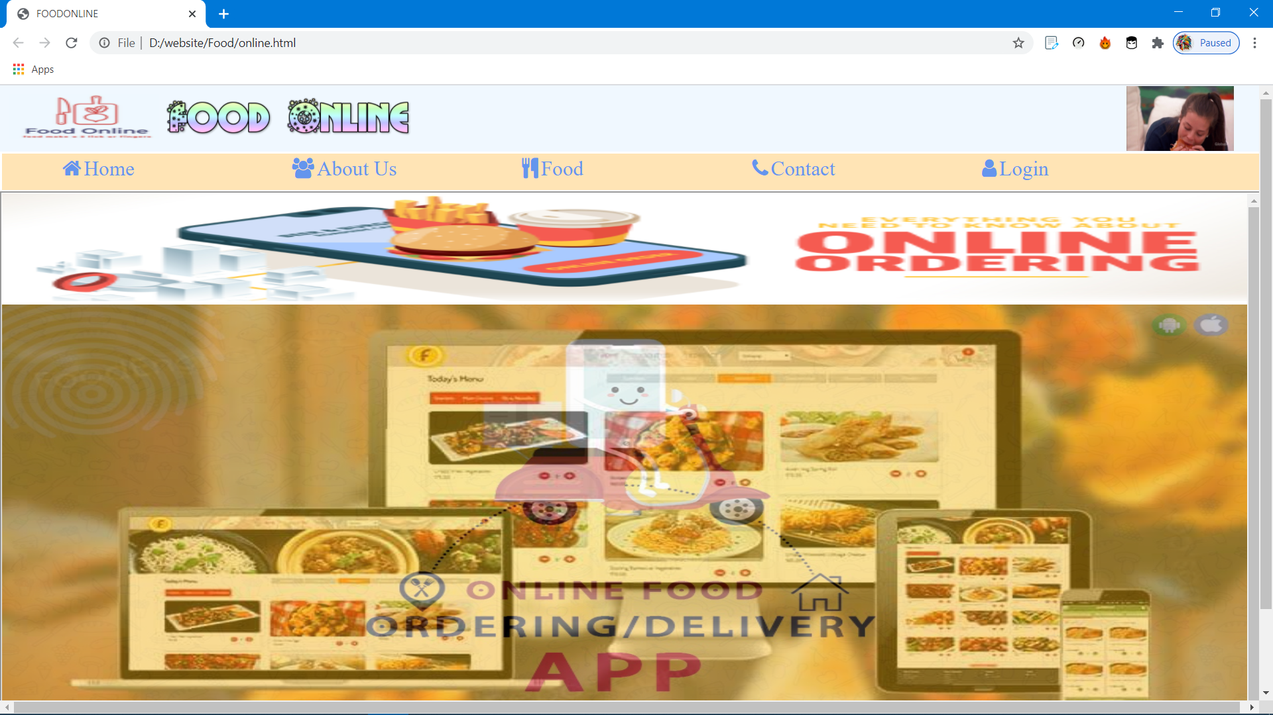

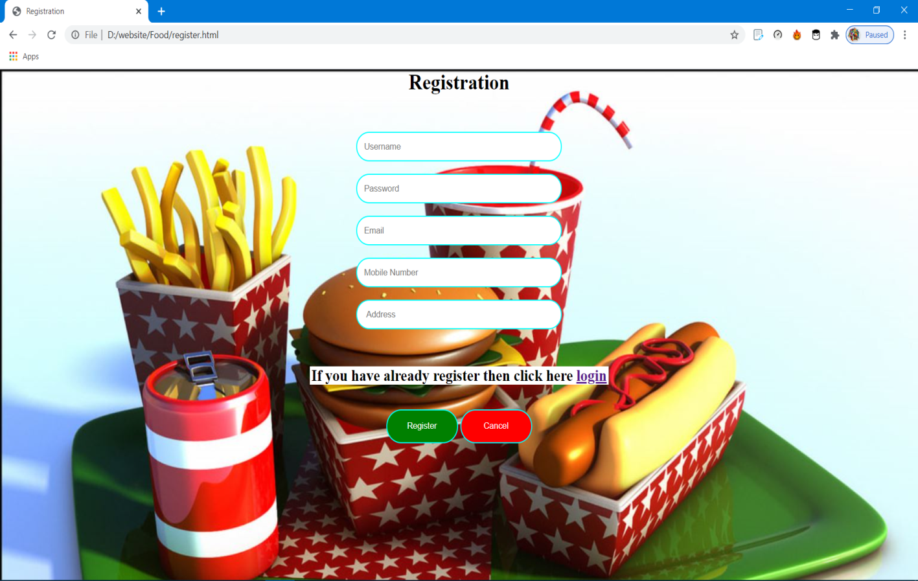

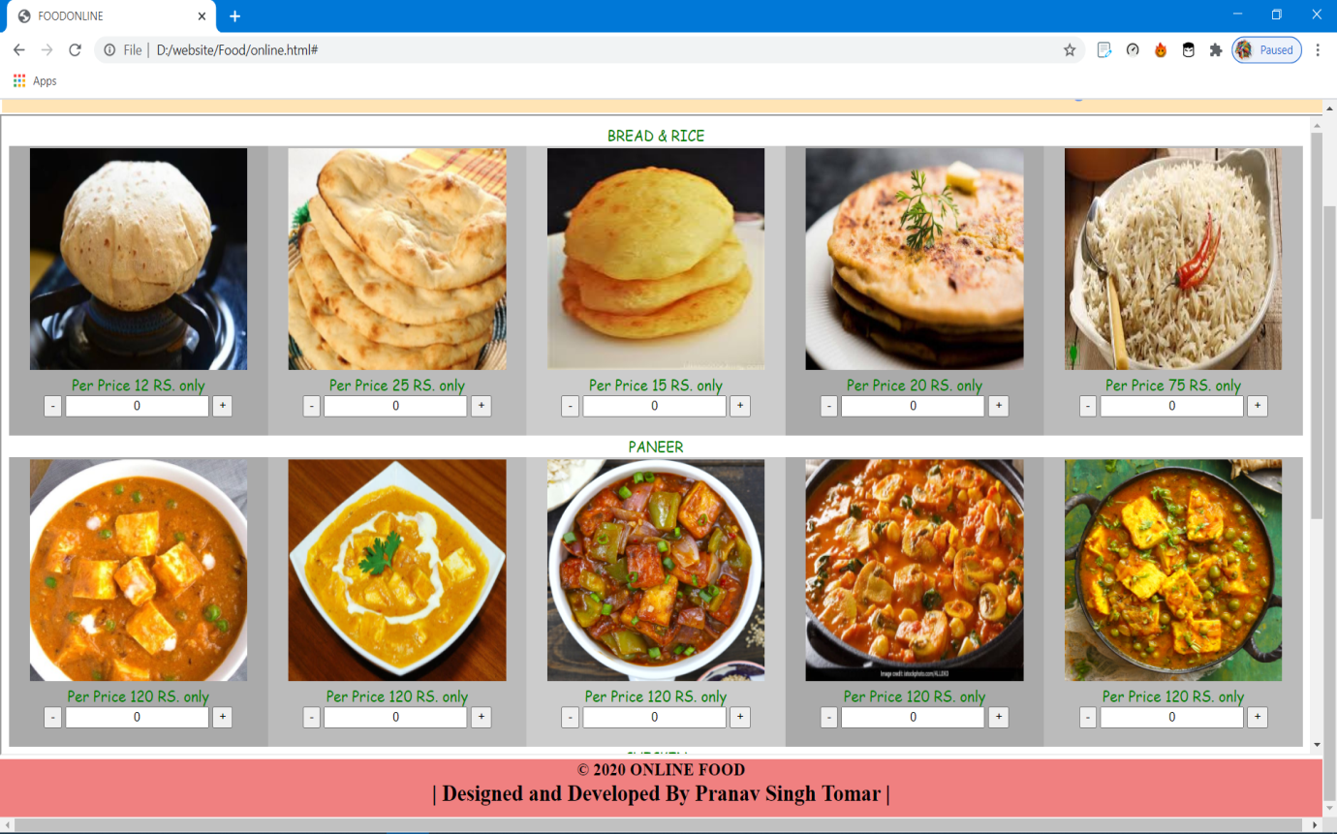

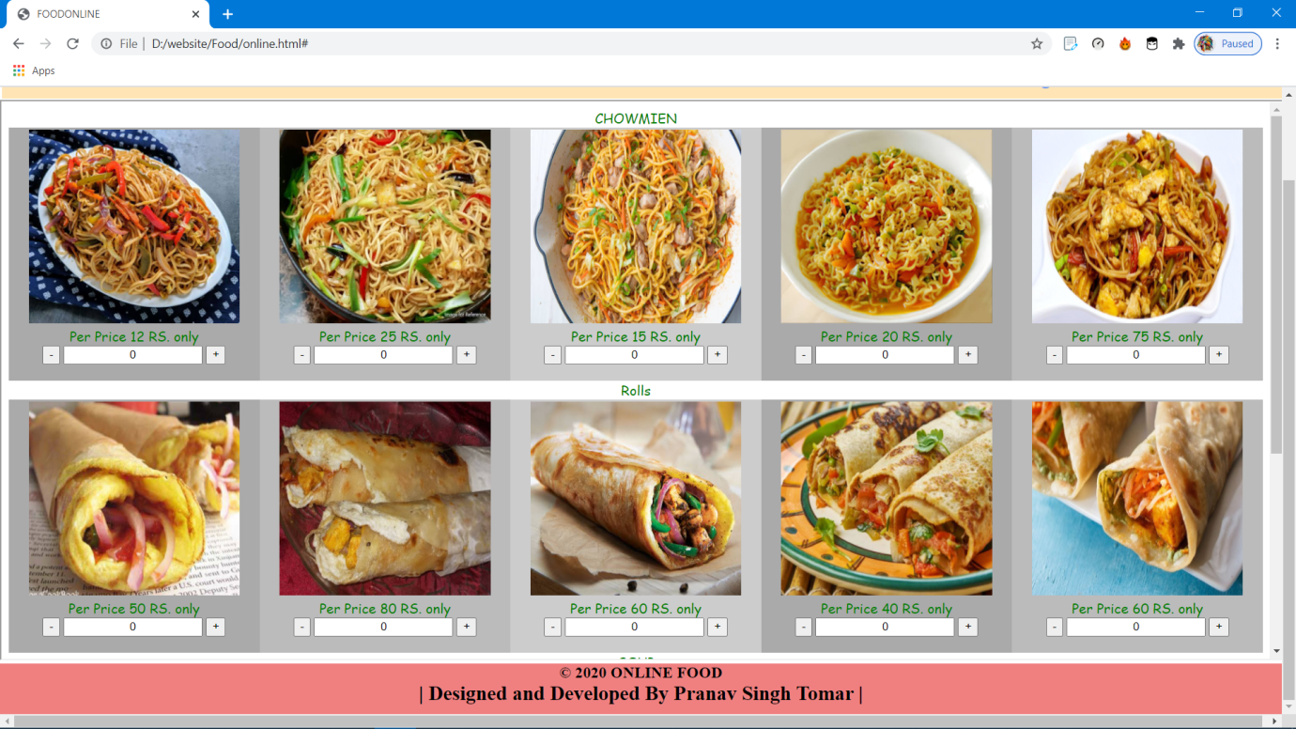

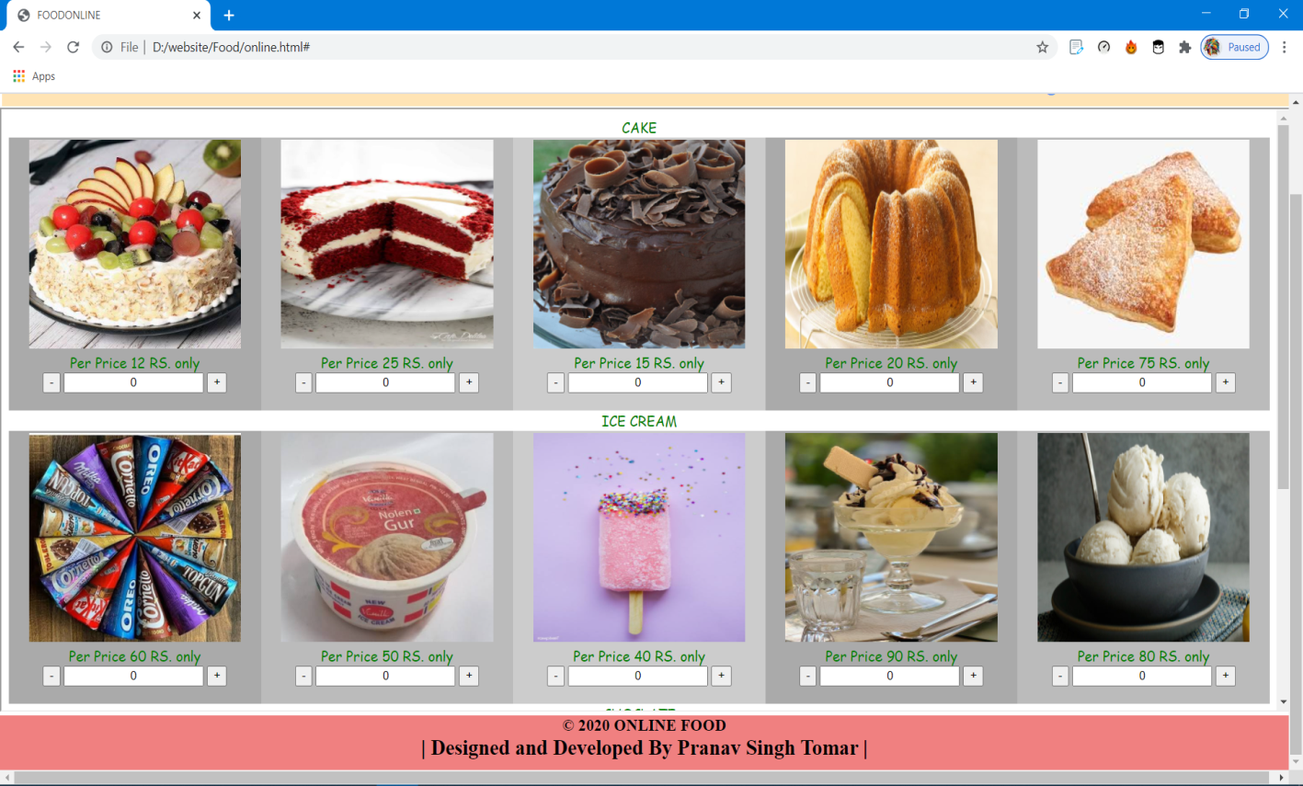

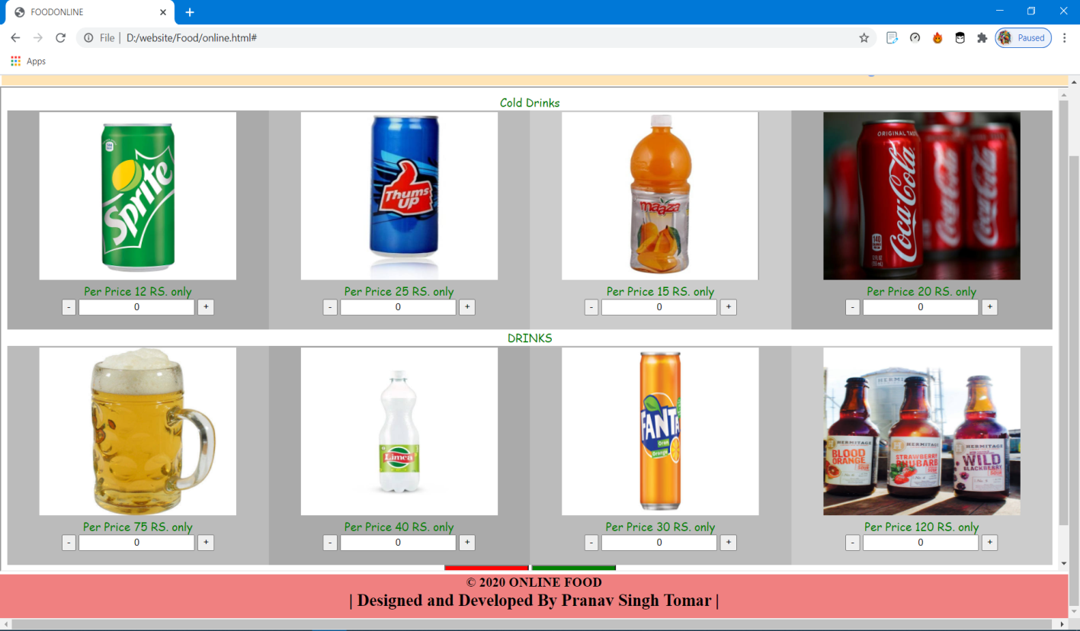

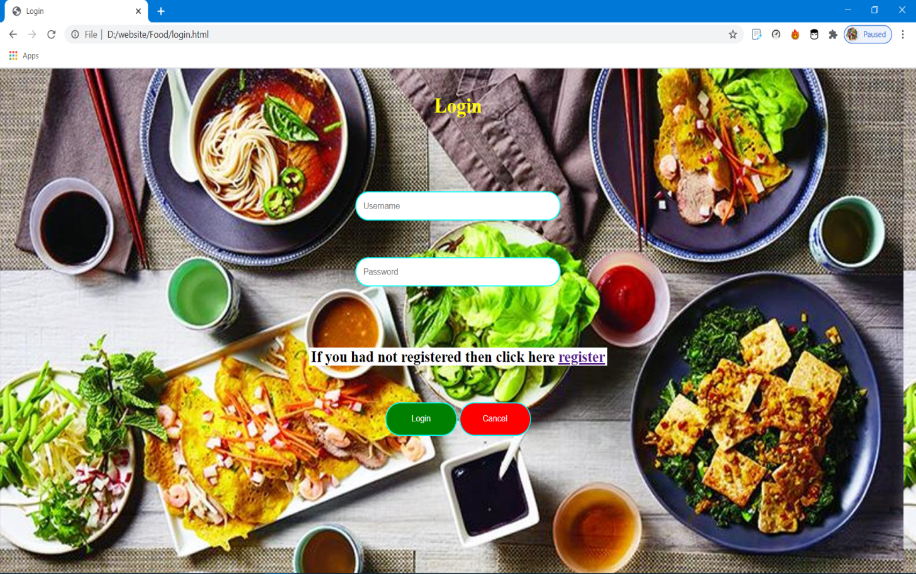

***Conclusion***

*The smart FOOD ONLINE is successfully designed and developed to fulfil the necessary requirements as identified in the requirement analysis phase, such as the system is very much user friendly , form level validation and field level validation are performing very efficiently .*

*The old manual system was suffering form a series of drawbacks. The FOOD ONLINE project has been developed on the basis of todays requirement and needs. It is a very easy way to manage the service in best way and provide best service .*

**THE END**